DREAMBRIDGE FINANCE, LLC
CONSUMER LOAN AGREEMENT AND PROMISSORY NOTE
(_________loan payable in five months made____________)

Parties:
Lender:
DreamBridge Finance, LLC, a Georgia limited liability company,
1327 Shiloh Trail East, N.W., Kennesaw, GA 30144.
Borrower:___________________________
Address: __________________________
Email: __________________________
Phone: __________________________
Driver’s License: ___________________
Social Security No./ Tax ID: ____________________
Guarantor: ____________________
Address: __________________________
Email: __________________________
Phone: __________________________
Driver’s License: ___________________
Social Security No./ Tax ID: ____________________
Principal Amount: Three thousand, one hundred dollars ($3,100.00).
Term: Five months
1. Loan Terms:
- Loan Amount: The Lender has loaned Borrower the amount of _________made on __________________.
- Interest Rate: The annual percentage rate (APR) applicable to this loan is 59%.
- Each payment installment: $_________
- Repayment: Borrower agrees to repay the loan in installments on the fifteenth (15th) and last day of each month, starting from _______________ (date first payment due) and ending on _______________ (date of final payment), unless the loan is paid in full earlier.
2. Disclosures and Compliance with Federal and State Regulations:
- Truth in Lending (Regulation Z): Borrower hereby receives information on the finance charge, the APR, the total of payments, and the payment schedule.
- Equal Credit Opportunity Act (Regulation B): The Lender shall not discriminate against Borrower on any prohibited basis under Regulation B, and Borrower has been advised of their rights under this regulation.
3. Payments:
- Payments shall be made to DreamBridge Finance, LLC at the address stated above or through electronic means as agreed.
4. Payment Schedule:
- Calculation of Installments:
  - Total interest for 5 months at 59% APR:
  - Amortization Table
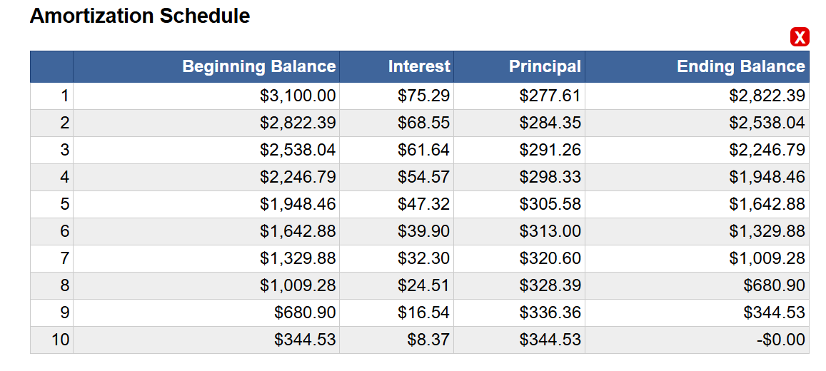
- Payment Amount on the 15th and last day of each month: $____________
- Due Dates:
  - First Payment:_____________.
  - Second Payment: ____________.
  - Third Payment: ______________.
  - Fourth Payment: _____________.
  - Fifth Payment: ______________.
  - Sixth Payment: ___________.
  - Seventh Payment: _____________.
  - Eighth Payment: _____________.
  - Ninth Payment: ____________.
  - Tenth Payment: ___________.
Note: Payments are scheduled to be made on the 15th and last day of the month. If additional payments are required beyond those listed, an additional payment schedule attachment may be provided.
5. Default:
- Borrower will be in default if any payment is not made within 10 days after its due date, or if Borrower breaches any other term of this Agreement. Upon default, all unpaid principal and accrued interest shall become immediately due and payable.
6. Prepayment:
- Borrower may prepay the loan in full or in part at any time without penalty.
7. Choice of Law and Forum Selection
- This Agreement shall be governed by, and construed in accordance with, the laws of the State of Georgia, without giving effect to principles of conflicts of law.
- Any dispute or claim arising out of or relating to this Agreement or the breach thereof shall be adjudicated exclusively in the state or federal courts located in Cobb County, Georgia. Both parties, including the Guarantor, consent to personal jurisdiction and venue in such courts.
8. Severability and Modification
- If any provision of this Agreement is determined to be invalid, illegal, or unenforceable by a court of competent jurisdiction, the remaining provisions shall remain in full force and effect. The parties agree that any invalid, illegal, or unenforceable provision shall be deemed modified to the minimum extent necessary to render it valid, legal, and enforceable.

- If any provision is found to impose interest, fees, or charges in excess of the maximum amount permitted by applicable law, such provision shall be deemed modified to reduce such interest, fees, or charges to the maximum amount permitted, and any excess amounts already paid by Borrower shall be applied to the principal balance or refunded to Borrower. Such determination shall not affect the validity and enforceability of any other remaining provisions.
9. Entire agreement:
- This Agreement constitutes the entire agreement between the parties with respect to the subject matter hereof and supersedes all prior negotiations, agreements, and understandings, whether written or oral, relating to such subject matter.

10. Attorney Fees:
- In the event of default and any action taken for collection or enforcement of this Agreement, Borrower and Guarantor agree to pay all reasonable attorney fees and costs incurred by Lender in connection with such actions. The amount of attorney fees recoverable by Lender shall be limited to that allowed by O.C.G.A § 13-1-11 or other applicable Georgia law.
11. Additional Provisions:
Military Lending Act Compliance:
- Disclosure of Military Status: Borrower represents and warrants that Borrower is NOT an active-duty member of the military, including those serving in the National Guard or Reserves when activated under federal orders for more than 30 consecutive days, or a dependent of such a member. For purposes of this Agreement, "dependent" is defined as a spouse, child under the age of 21, or an individual for whom the service member provided more than one-half of the individual's support for the previous 180 days.
  - Military Annual Percentage Rate (MAPR) Cap: If Borrower is covered by the Military Lending Act (MLA), the Military Annual Percentage Rate (MAPR) for this loan shall not exceed 36%, inclusive of all fees, charges, and interest.
  - Oral Disclosures: If Borrower is a covered individual under the MLA, Lender shall orally provide the information detailed in the written disclosures, either in person or via a toll-free telephone number provided by Lender.
  - Verification: Borrower must notify Lender of any change in military service status immediately. Lender may at any time check Borrower's status against the Department of Defense's Military Lending Act Database or through other means to verify Borrower's military status.
  - Non-Applicability: If Borrower is not a covered borrower under the MLA, this provision does not alter the terms of this Agreement, but Borrower must still disclose their status at the time of loan origination and upon any change in status.
  - Breach of Disclosure: If Borrower fails to disclose or falsely discloses their military status, this may be considered a breach of this Agreement, subjecting Borrower to potential legal action or adjustment of loan terms to comply with the MLA if subsequently discovered.
- Rule 80-14-5-.01 Compliance: This Agreement includes all disclosures required by Georgia regulations regarding loan contracts, ensuring that all terms, conditions, and obligations are clearly stated.
- Electronic Records and Signatures: Borrower and Guarantor consent to electronic records and signatures in accordance with the Uniform Electronic Transactions Act where applicable.

12. Joint and Several Unconditional Guaranty:
- The Guarantor hereby unconditionally guarantees to Lender, jointly and severally with Borrower, the prompt payment of all obligations of Borrower under this Agreement, including but not limited to principal, interest, fees, and any amounts due upon default. This guaranty is absolute, irrevocable, and continuing and shall remain in full force and effect until all obligations under this Agreement have been fully satisfied.
- The Guarantor agrees to be bound by all terms of this Agreement as if they were the principal obligor, including the forum selection clause and choice of law provisions. The Guarantor waives any right to require the Lender to proceed against Borrower or any other Guarantor, to pursue any other remedy, or to enforce any other right before enforcing this Guaranty. The Lender may enforce this Guaranty independently of any action against the Borrower.
13. Spanish translation:
A Spanish translation of this Agreement is simultaneously provided; however, in case of any consistency or ambiguity between the English and Spanish text, the English language Agreement shall prevail.
By signing below, Borrower and Guarantor, if any, acknowledge receipt of all required disclosures, understands the terms of this Agreement, and agree to be bound by its terms.
BORROWER:  Signature: _____________________________  Print name: ________________  Date: _______________ | LENDER:  DREAMBRIDGE FINANCE, LLC  _______________________________  By: Cecilia Garcia  Lender  Date: _______________
GUARANTOR:
Signature: _____________________________
Print name: _____________________________
Date: _______________

